42.42: The vibration frequency is, from Eq. (42.8), 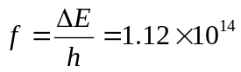Hz. The force constant is
